APPLICATION FOR RELEASE

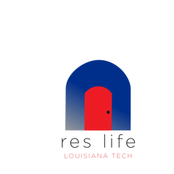

The deadline for submitting the Lease Release Form each quarter is listed below
To be released from:
Fall 2019 - Application due by: Aug 9th @ 5pm
Winter/Spring 2019 - 2020 - Application due by: Nov 8th @ 5pm
Spring 2020 - Application due by: Feb 21st @5pm

This form must be submitted for review 2 weeks before you wish to be released.

PLEASE COMPLETE THE FOLLOWING INFORMATION:

Name: _______________________________________________________________________
(Last) (First) (Middle)

Student Number: ________________________

Current Assignment: ________________________________ Cell Phone #: ______________

Classification: ___________________________________

Current Lease Begin Date: _________________________

Current Lease End Date: _________________________

Requested Departure Date: _________________________

Check the reason for your lease release request:

Graduation/Completion of Degree Requirements – Must file intention to graduate with
the University Registrar’s Office.

Separation from the University – Registration status will be verified.

Financial – Must provide documentation verifying an unexpected change that has taken
place in your financial status since signing the lease. Documentation must indicate an
inability to meet financial obligations of the contract as a result of this change.

Other - ________________________________________________________
(Provide a detailed explanation on the reverse of this page.)

Please provide a detailed explanation of your circumstances by answering the questions below. Attach additional pages if necessary.

- What has changed in your situation since signing the lease agreement? Please be as specific as possible and provide documentation.

- How does this affect your ability to continue your obligation to the lease agreement?

By signing below I verify that all information contained in this document is true and accurate.

SIGNATURE ________________________________ DATE: _____________________

Please return the completed form and all supporting documentation to our office, 227, in WYLY Tower,

Approval for off campus must come from the Student Affairs Office located in Keeny 305.

